Title or Task: | Title Drawing in Word  

Description:

Files Required
Suitable for Classes: | All classes
Area: | Technology & Enterprise
Teacher: | Mr Peter Faulks

Timeline

Date Due:

Task Brief:

Outcomes:

Items highlighted in yellow are tasks for you to complete
Items in Blue italics are help tips

Worksheet Drawing in Word or Power Point

Drawing in Word or Power Point can be a more powerful aspect than you might
imagine, if you do noy have Corel, Adobe or a dedicataed drawing package then Word or Power Point is your answer, and you may be surprised at how powerful it can be… this student has given permission to use her face in all teaching sessions…


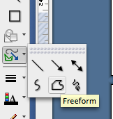
Lets say we wish to copy this into an Avatar Cartoon Face

First lets look at the FREEFORM TOOL

This tool used with EDIT POINTS is very usefull

WHEN WORKING USE 200% to help you work points and drawings

Using our picture and the freeform tool draw a rough circle over the face using as many click poins as possible, then select the circle and make it slightly transparent with a face colour fill - this is the colour I used. 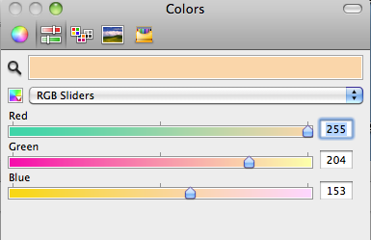


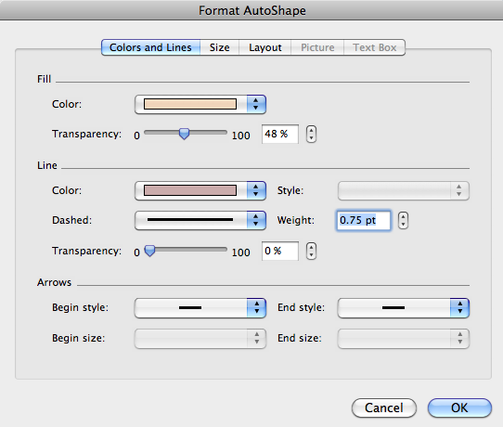

I used about 50% transparency select the rough circle - now click on EDIT POINTS

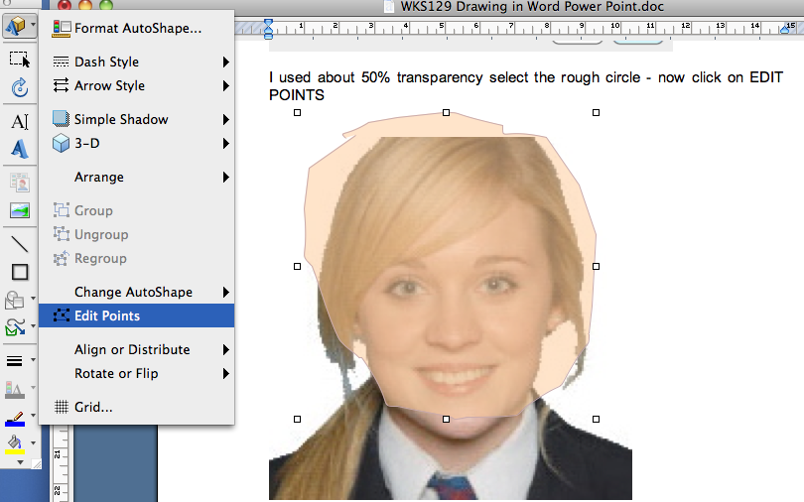

We can use these points like a PEN TOOL

Click on each point and move them in to fit the shape of the face, just above the hair line, we will work our way around the face. Use RIGHT MOUSE to bring up the contextual menu.

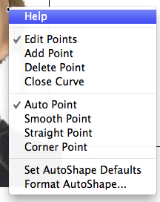

Drag one of the vertexes that outline the shape. A vertex is the point, indicated by a black dot, where a curve ends or the point where two line segments meet in a freeform shape.
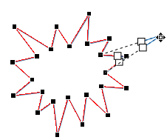
Working with editing points
- To add a point, click the shape outline while pressing Ctrl.
- To delete a point, click the point while pressing Ctrl.
- To have the point treated as a smooth point, press Shift while dragging either of the handles attached to the point. Once you stop dragging, the point will be changed to a smooth point. A smooth point joins two line segments of equal length.
- To have the point treated as a straight point, press Ctrl while dragging either of the handles attached to the point. Once you stop dragging the point will be changed to a straight point. A straight point joins two line segments of different lengths.
- To have the point treated as a corner point, press Alt while dragging either of the handles attached to the point. Once you stop dragging the point will be changed to a corner point. A corner point joins two line segments with one segment going off in a different direction.
- To cancel the change to the point and line segments, press Esc before releasing the mouse button.
- To open Edit Points mode with keyboard shortcuts, select the shape and then press Alt + JD, E, E.
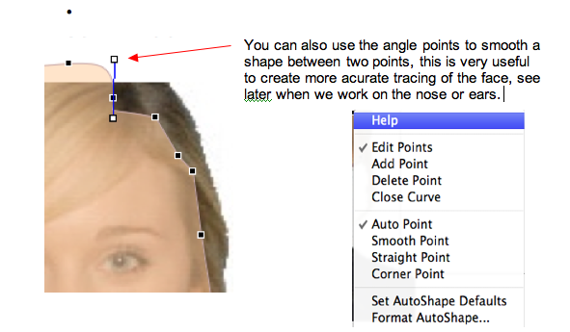

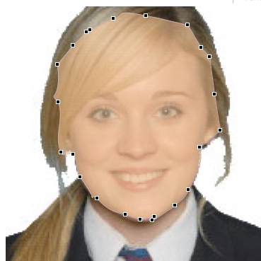

The Face
Now we can create the eyes, use the FREEFORM TOOL to draw a shape around the eye, you can use simple eyes but I prefere the effect eyes.
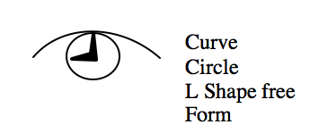

Use the freeform to draw the outside
of the eye
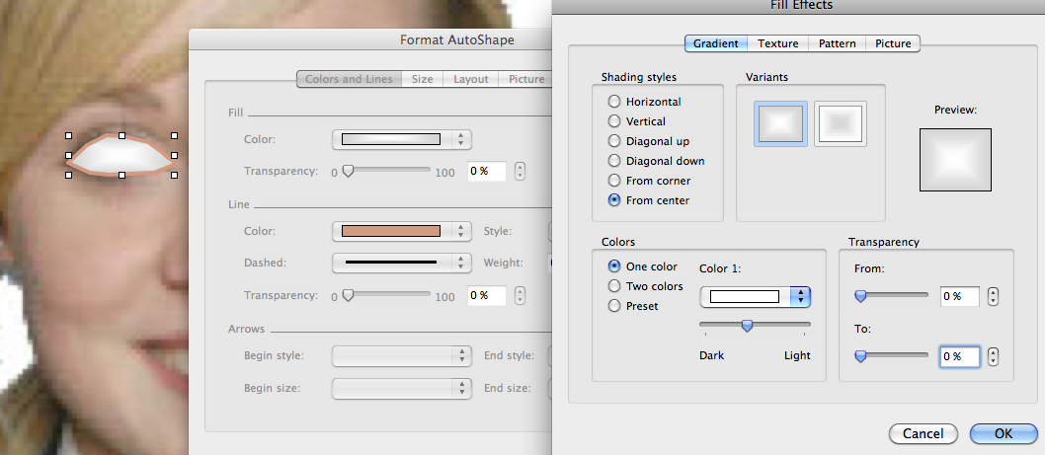
Use Edit Points to shape the eye

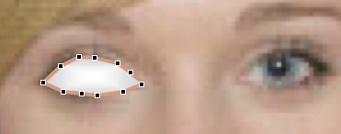

Select Line and pick a colour brown to add shape to eye with Gradient tool Circle and, add a circle for the Pupil and then add a circle for the eyeball using similar colour and gradient from center.

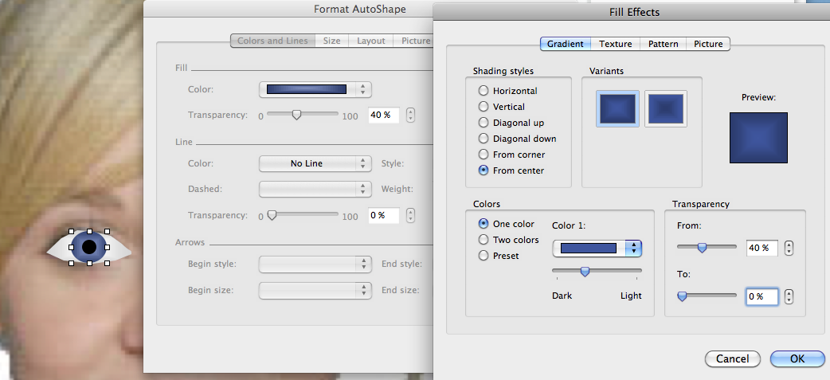

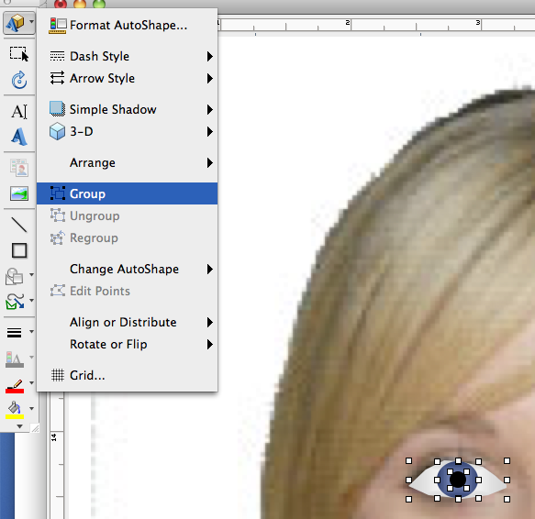
Add a highlight to the eye then group and copy the eye paste twice the second eye flip horizontal, use the picture and face and then place the eyes on top, They may need sizing down.

Match the eyes to size and place, now we work on the nose, using the FreeForm Tool draw a shape close to the nose but extend out to each eye as this will form the shape for eyebrows. Add a gradient then add the nostrils.

Now we can create the lips and teeth Top Lip using free form and edit points fill with red

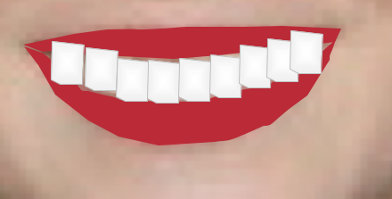



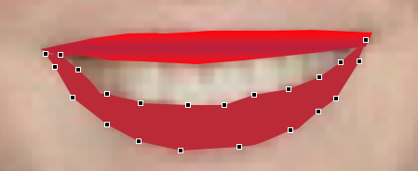

Teeth use free form fill with white with light grey outline bring lips over (to front of teeth)

Insert some eyebrows and shading for eyes

Next the hair which you should now be able to undertake yourself

Parts

Now make your face, add some shading to the face and become creative.

Drawing can help create interest in a presentation. Drawing tools can also be used to create diagrams and schemes. Drawing tools include shapes, lines, and text boxes.
Enter Text
Proof Text
Preview Text
Print Text

WordArt is a great way to format text to give it extra special impact.

WordArt
is fabulous for

extra special formatting

In this section you will

- Create Drawing Objects
- Create WordArt Objects
- Format and work with Drawing and WordArt Objects

The Drawing Toolbar

All the examples on the introduction page were produced using the Drawing Toolbar.

The Drawing toolbar is usually located at the base of the screen.

- If you cannot see the Drawing toolbar click on View ➢ Toolbars ➢ Drawing to display it

To Draw an Object

We will start with some basic shapes then move onto some of the AutoShapes.

- Open or display the file Drawing

- Add a New slide with a Blank layout
- Click on the Rectangle button in the Drawing Toolbar

- Move the mouse to the slide then click, hold and drag the mouse over the slide.

As you drag the mouse, the outline of the shape will appear.

- Release the mouse when you are satisfied with the size

- Repeat the procedure for the Oval and Line buttons. You could try to draw the example below

Using Text Boxes

The Text Box tool is useful for inserting extra text on a slide.

- Click on the Text Box button - then click on the screen where the text is to appear

When you release the mouse the insertion point will be ready to type some text.

- Type the text below or something of your own in the Text box.

As you type the text box will increase in size to accommodate the text. When you have finished typing you can resize the box to the appropriate dimensions.
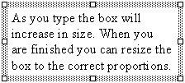
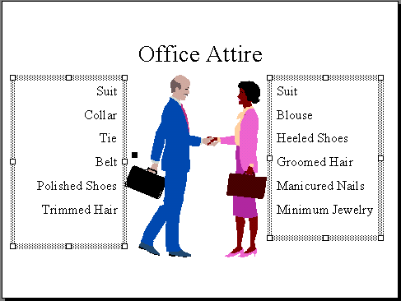
- Display the slide with the Title Office Attire

- Insert a text box and enter the text as shown on the left of the slide - use the Right Align button on the formatting toolbar to line the text up on the right

- Insert a text box and add the text as shown on the right of the slide

To Draw an AutoShape

- Add a New slide with Blank layout
- Click on the AutoShapes button on the Drawing toolbar to display the AutoShapes List

- Point to Block Arrows
- Click on the Right Arrow Tool shape on the AutoShapes Toolbar

- Position the mouse to the left of the slide, click, hold and drag over and down to the lower right to draw the arrow, release the mouse

If you look closely at the arrow while it is selected you will notice a small diamond. This appears for some of the AutoShapes. It indicates that the shape is adjustable.

The mouse changes to just an arrow head which indicates you can adjust the AutoShape

- Drag the diamond to the left to adjust the arrow head

- Practice with some other AutoShapes

Working with Drawing Objects

To work with objects we have to select them first.

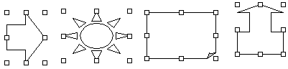To Select an object

- Click on a visible part of the object (but not over the text if there is text) - the resize handles will appear

To Deselect an Object
- Click on a blank area of the slide

- Practise selecting and deselecting each object on the slide

Selecting Multiple Objects

We can select objects together. This is helpful if we want to maintain positioning relative to each other but want to alter placement of the set. We use the [Shift] key on the keyboard to select multiple objects.

- Click on the first drawing object
- Press the [Shift] key down and hold
- Click on another object
- Continue to click on all the shapes or objects you have drawn while still holding the [Shift] key
- Release the [Shift] key

Your selection should look like this.

- To deselect any object just click on it again while holding the [Shift] key
- To deselect all the shapes at once just click on a blank area of the document
- Deselect all the objects to return to normal

Colours and Styles of Lines and Drawing Objects

The Drawing toolbar also enables us to apply various colours and styles to our Drawing objects.

Fill Colour
Drop list button
All drawing objects can be coloured in.

- Click on the drawing object
- Click on the Fill Colour drop list button and choose a colour

Line Colour
All lines and outlines of drawing objects can be coloured.

- Click on the line or drawing object
- Click on the Line Colour button and choose a colour

Shadow
We can give drawing objects a shadow.

- Click on the drawing object
- Click on the Shadow button to give the object a shadow

Line Style
Lines can be various thicknesses and styles.

- Click on the line or drawing object
- Click on the Line Style button and choose a style

Arrow heads
There are various sizes of arrowheads we can apply to lines.

- Click on the line
- Click on the Arrow Style button and choose an arrow head style

Dashed Lines
There are various types of dashed lines we can apply to the lines we have drawn.

- Click on the line
- Click on the Dash Styles button and choose a line type

Arcs and Rotations

We can achieve some fantastic effects using Arcs and Rotations. An Arc is a line with one curve that can be from anywhere as round as a circle right out to virtually a straight line.

Drawing and Editing an Arc Object

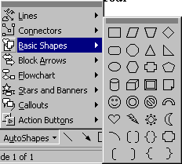PowerPoint enables us to draw and edit arcs with the Arc Tool located in the AutoShapes.

- Add a New slide with a Blank layout

- Click on the Arc Tool

- Move the mouse over the slide - notice it has become a cross hairs 

- Drag from the top left down to the lower right

You should have an arc that looks like the top left arc below.
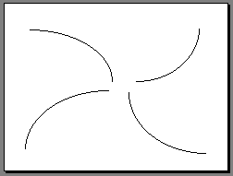

- Try the other directions as shown - each time you draw a new arc you must click the arc tool again

Editing the Roundness of an Arc

We change the roundness of an arc line by dragging the line to the required shape.

- Position your pointer on the arc line and click to select it

Resize handles will appear around the line

- Click on the left resize handle and drag further to the left

As you drag a broken line will indicate where the line will be and the shape it will take if you release the mouse at that particular point.

- See if you can edit the arcs to appear as below.

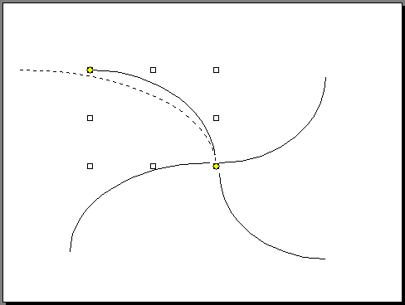

Edit the Angle of an Arc

So far the Arcs we have created are only the curve of an ellipse for an angle of 90 degrees. We can increase or decrease the angle of the curve, ie an arc that was virtually a circle would have an angle of nearly 360 degrees.

To change the angle

- Resize the arc to small as shown below

- Click on the yellow handle at the end of an arc line - a handle will appear at each end of the arc line

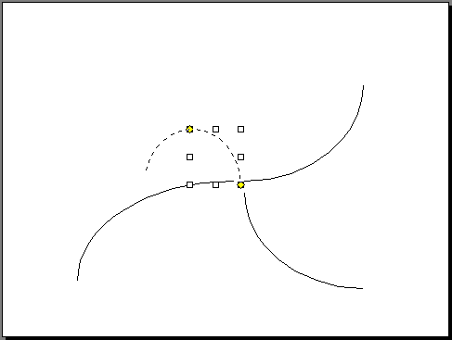
- Drag one of the handles around to increase the angle of the arc

- Click anywhere off the line to deselect it

- Try to form the shape shown to the left with the four arcs you produced before - you may need to change the roundness as well to get the four small circles

Practice Exercises

5.1 Display the slide Distribution Network and draw the arc lines them format them to be dotted

5.2 Add a new blank slide and create the following drawing

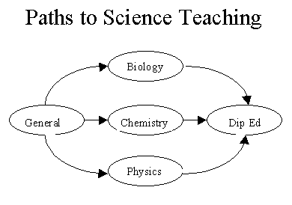

Hint : The text is in a text box over an oval shape. The text box has no border.

Drawing a Freeform Object

A Freeform object is a combination of our efforts at freeform lines and if required straight lines.

Free Form

Auto Shapes

Straight Line
- Add a New slide with a Blank layout
- Click on AutoShapes ➢Lines then the Freeform Tool

- Click on the starting point for your shape - release mouse button

- Click on the next point, release

- Continue until you form a square or rectangle

Freeform
- Click on the Freeform tool

- Click on the start point, drag the mouse to make design, the mouse will have changed to a pencil

- To turn off the Freeform tool to finish a line just double click

- Try drawing a daisy - or if you’re adventurous try the teddy above

Once created, a freeform line is like any other drawing shape that can be formatted, moved etc.

Rotating and Flipping Objects

Drawing objects can be flipped and rotated to the required aspect.

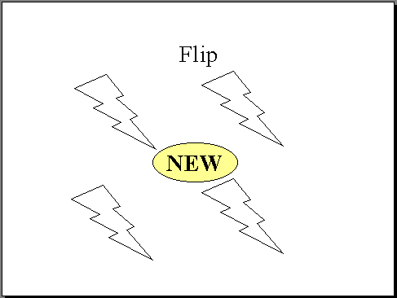
- Click on the slide Flip

This slide has four bolts of lightning however three of them face the wrong way. They must be rotated or flipped so they face the required direction as shown below.

- Select the object in the top right corner

- Click on Draw ➢ Rotate or Flip in the Menu Bar
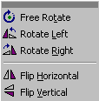

- Click on the Rotate Right button

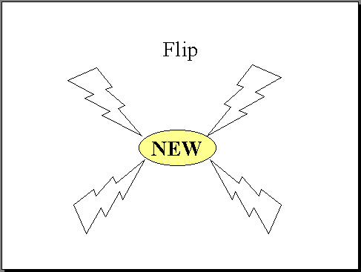
- Try rotating the other bolts with the rotate and flip tool buttons so the slide appears as below

Free Rotation

The Free Rotate Tool allows us to rotate the drawing object to any angle.

- Display the slide Free Rotate

- Select the Shape

- Click on Draw➢Rotate or Flip ➢Free Rotate on the Draw menu

Rotate handles will appear around the shape.

- Click on one of the corner handles as shown below and drag, an outline will indicate the position

- Release when happy with position
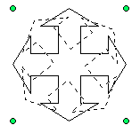
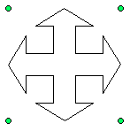
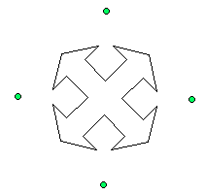
Free Rotate handle

- Display the slide Arrow Colour Logo No 1 and rotate to appear as to the right
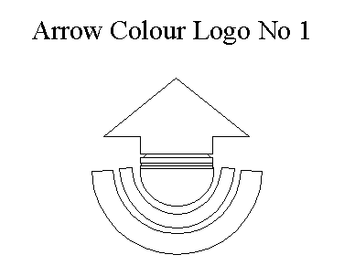
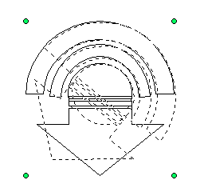

Copy a Drawing Object

Any object that is selected can be copied then pasted elsewhere in the presentation. We will try it with the Arrow, making a copy for the same slide

- Display the slide Copy and Click on the Arrow shape to select it

- Click on Copy button in the toolbar OR Edit ➢ Copy in the Menu Bar

- Click on Paste in the toolbar OR Edit ➢ Paste in the Menu Bar

A copy of the arrow will be pasted to overlap the original arrow. It will be selected. Now we can just move it to the correct position on the slide

Move a Drawing Object on the same slide

Drawing objects can be moved the same way that ClipArt can.

- Position the mouse pointer over the top of the drawing object

- Click, hold and drag the object to the required position

Move a Drawing Object to another slide

- Select the object to be moved

- Click on Cut in the toolbar OR Edit ➢ Cut in the Menu Bar

- Display the slide where the object is to be placed

- Click on Paste in the toolbar OR Edit ➢ Paste in the Menu Bar

- Practice moving and copying the drawing objects you have created.

Grouping and Ungrouping Drawing Objects

Objects can be grouped together so that we can move or copy them easily.

- Add a new blank slide and draw the following set of shapes

Suppose we wanted to move the shapes one centimetre to the right. What a nuisance. However if they are grouped together their positions relative to one another will be maintained.

- Click on the first shape to select it

- Hold down the [Shift] key and click on the other shapes
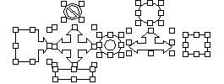

- Click on the Draw Menu button then the Group button
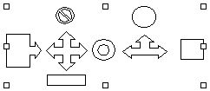
Notice the resize handles are now just around the whole group.

- Move the group – all the shapes should move together

- Click on the Draw button then the Ungroup button to return the objects to be individual objects

- Click on a blank area of the slide to unselect all the objects

Stacking Objects

You can change the order of objects in a stack.

- Display the slide Stacking

- Click on the circle to select it

- Click on the Draw button in the Drawing toolbar

- Point to Order to display the Stacking buttons
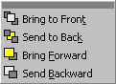
- Click on the Send to Back button

The circle will be on the bottom of the stack.

- Click on Draw➢Order➢ Bring to Front button

The Shape will back on top. Several shapes can be ordered by using the Bring Forward and Send Backward button.
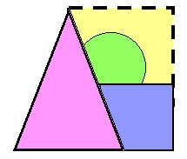

Practice Exercise
Dream Card

- Create the following set of objects as an outline for a logo
- Use the stacking buttons so they are in the correct order
- Group the objects together so they are set in place

Practice Exercises

5.3 Arrow Staff Induction

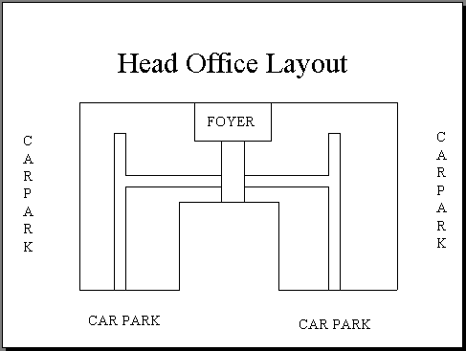
- Open the file Arrow Staff Induction and add the slide to the right

- Add another new slide with Title layout

- Enter the title Arrow Company Logo

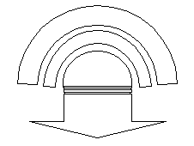
- Draw the following

- Save and Close the presentation when finished

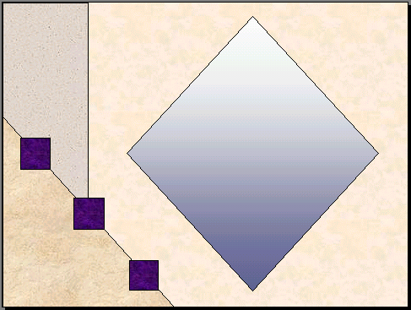
- Start a New presentation with a Blank slide layout

- Use the drawing objects and stacking features to create this slide that could be used as a background

- Save the presentation as Background

- Close the file when finished

Inserting WordArt

WordArt is a small program that enables us to do wonderful things with text. The text used in WordArt is an object and thus can be moved around, resized and edited at any time.
Just
try
it!
Here are some examples of WordArt.

WordArt
It's easy

WordArt is inserted into a slide via a button on the Drawing toolbar.

- Add a New slide with a Blank layout

- Click on the WordArt button on the Drawing toolbar at the base of the screen

The WordArt Gallery will appear.

- Click on a style box to choose a WordArt style then click OK
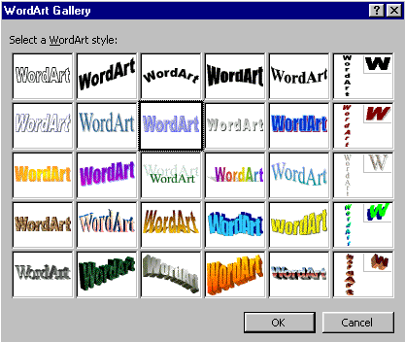

The Edit WordArt Text box appears. This is where you type the text you want to be in the WordArt.

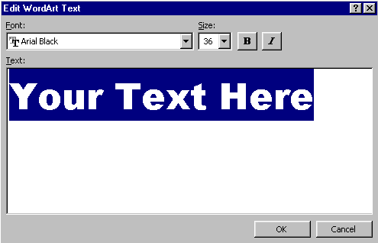

- Type the word PowerPoint then click on OK

The text now appears on the slide as shown below. The WordArt toolbar may also appear.
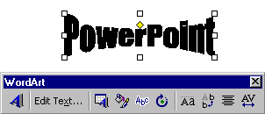
The WordArt toolbar

- Click on View ➢ Toolbars ➢ WordArt to display the WordArt toolbar if it is NOT on the screen

Formatting WordArt

We can format the text in the WordArt the normal way ie. changing the font style and size. However the great feature with WordArt is the way we can shape the text with the tools on the WordArt toolbar.

Eg.

The WordArt Toolbar

The WordArt toolbar usually appears when the WordArt object is selected.

- Click on View ➢ Toolbars ➢ WordArt to turn on the WordArt toolbar if it is NOT on the screen

Rotates characters on side
Rotate
words
Colour and pattern on text

Expand to fit frame
Insert another WordArt object
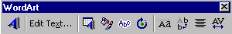
Change shape
Change text, font and size, use bold or italic
Capitals same size as lowercase
Centre text in frame

- Experiment with the options on the WordArt Toolbar

- When finished click outside the WordArt object to deactivate it - now you can work with PowerPoint as normal

To Resize WordArt

WordArt, like any other Object such as ClipArt or a Drawing object, can be moved and resized.

- Click on the WordArt object

The WordArt object appears with resize handles.

- Move the mouse over the resize handle until a double - headed arrow appears

- Click on the resize handle, hold and drag to the required size

Resize handles

To Move WordArt

- Move the mouse over the top of the object, click, hold and drag to desired position

To Edit WordArt Text

The WordArt object must be activated to edit the text or any of the formatting in the object.

- Double Click on the WordArt object to activate it - the WordArt Toolbar will appear again

- Make selections as normal then click outside the WordArt area to deactivate it.

- For practice create the rest of the WordArt shapes to create the following sentence (you will create four separate WordArt objects)

Eg.


Need help just ask
F
aulks
P
eter

